weights = [1.5, 0.5, 1.0]

1 run...

<tqdm.auto.tqdm object at 0x7fa9b3708a10>

<tqdm.auto.tqdm object at 0x7fa9b3f06250>

training 1 epoch...

237.81545662879944 seconds used......

1 training finished! average train loss: 0.5976952117264406

evaluating...

Confusion matrix, without normalization

[[ 784 89 149]

[1550 3666 191]

[1319 221 9225]]

Normalized confusion matrix

[[0.76712329 0.08708415 0.14579256]

[0.28666543 0.67800999 0.03532458]

[0.12252671 0.02052949 0.8569438 ]]

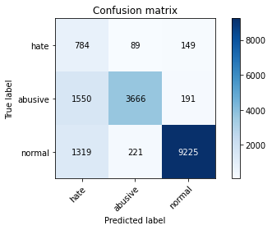

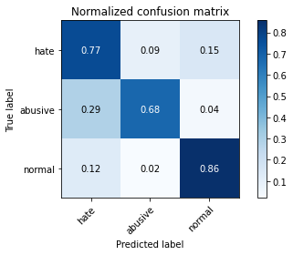

precision recall f1-score support

hate 0.21 0.77 0.34 1022

abusive 0.92 0.68 0.78 5407

normal 0.96 0.86 0.91 10765

accuracy 0.80 17194

macro avg 0.70 0.77 0.67 17194

weighted avg 0.91 0.80 0.83 17194

average eval_loss: 0.5068047010621359, accuracy: 0.7953355821798301

training 2 epoch...

237.24854612350464 seconds used......

2 training finished! average train loss: 0.435102052919348

evaluating...

Confusion matrix, without normalization

[[ 766 105 151]

[1362 3882 163]

[1171 218 9376]]

Normalized confusion matrix

[[0.74951076 0.10273973 0.14774951]

[0.25189569 0.7179582 0.03014611]

[0.10877845 0.02025081 0.87097074]]

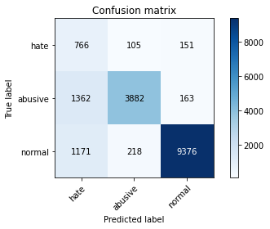

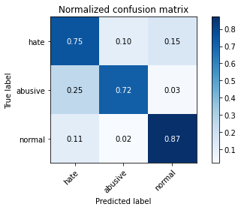

precision recall f1-score support

hate 0.23 0.75 0.35 1022

abusive 0.92 0.72 0.81 5407

normal 0.97 0.87 0.92 10765

accuracy 0.82 17194

macro avg 0.71 0.78 0.69 17194

weighted avg 0.91 0.82 0.85 17194

average eval_loss: 0.4689326677817938, accuracy: 0.8156333604745841

training 3 epoch...

237.25007343292236 seconds used......

3 training finished! average train loss: 0.30780201969546334

evaluating...

Confusion matrix, without normalization

[[ 758 97 167]

[1526 3667 214]

[1209 216 9340]]

Normalized confusion matrix

[[0.74168297 0.09491194 0.16340509]

[0.28222674 0.67819493 0.03957832]

[0.11230841 0.02006503 0.86762657]]

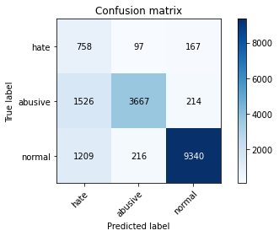

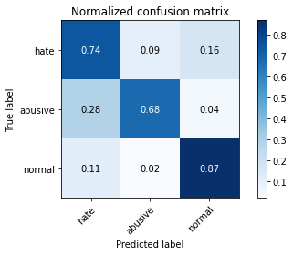

precision recall f1-score support

hate 0.22 0.74 0.34 1022

abusive 0.92 0.68 0.78 5407

normal 0.96 0.87 0.91 10765

accuracy 0.80 17194

macro avg 0.70 0.76 0.68 17194

weighted avg 0.90 0.80 0.84 17194

average eval_loss: 0.5274115256445352, accuracy: 0.8005699662673026

training 4 epoch...

237.25356769561768 seconds used......

4 training finished! average train loss: 0.20045354782811808

evaluating...

Confusion matrix, without normalization

[[ 708 134 180]

[1253 3956 198]

[1148 261 9356]]

Normalized confusion matrix

[[0.6927593 0.13111546 0.17612524]

[0.23173664 0.73164416 0.0366192 ]

[0.1066419 0.02424524 0.86911287]]

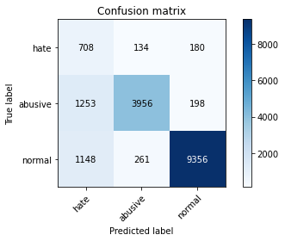

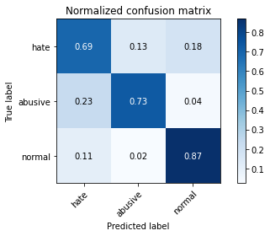

precision recall f1-score support

hate 0.23 0.69 0.34 1022

abusive 0.91 0.73 0.81 5407

normal 0.96 0.87 0.91 10765

accuracy 0.82 17194

macro avg 0.70 0.76 0.69 17194

weighted avg 0.90 0.82 0.85 17194

average eval_loss: 0.5538136022425322, accuracy: 0.8154007211818076

training 5 epoch...

237.39936780929565 seconds used......

5 training finished! average train loss: 0.14332265717568166

evaluating...

Confusion matrix, without normalization

[[ 761 119 142]

[1653 3626 128]

[1680 293 8792]]

Normalized confusion matrix

[[0.7446184 0.11643836 0.13894325]

[0.30571481 0.67061217 0.02367302]

[0.15606131 0.02721784 0.81672085]]

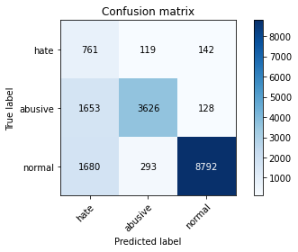

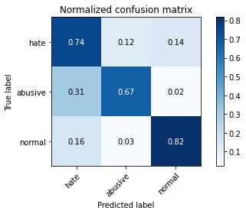

precision recall f1-score support

hate 0.19 0.74 0.30 1022

abusive 0.90 0.67 0.77 5407

normal 0.97 0.82 0.89 10765

accuracy 0.77 17194

macro avg 0.68 0.74 0.65 17194

weighted avg 0.90 0.77 0.81 17194

average eval_loss: 0.758004411675989, accuracy: 0.766488309875538

2 run...

training 1 epoch...

237.3366219997406 seconds used......

1 training finished! average train loss: 0.5960930456022646

evaluating...

Confusion matrix, without normalization

[[ 733 118 171]

[1263 3936 208]

[1169 236 9360]]

Normalized confusion matrix

[[0.71722114 0.11545988 0.16731898]

[0.23358609 0.72794526 0.03846865]

[0.10859266 0.0219229 0.86948444]]

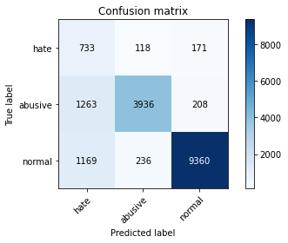

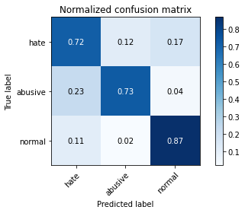

precision recall f1-score support

hate 0.23 0.72 0.35 1022

abusive 0.92 0.73 0.81 5407

normal 0.96 0.87 0.91 10765

accuracy 0.82 17194

macro avg 0.70 0.77 0.69 17194

weighted avg 0.90 0.82 0.85 17194

average eval_loss: 0.46436114543399143, accuracy: 0.8159241595905549

training 2 epoch...

237.47261023521423 seconds used......

2 training finished! average train loss: 0.43185473151050896

evaluating...

Confusion matrix, without normalization

[[ 773 72 177]

[1731 3524 152]

[1109 215 9441]]

Normalized confusion matrix

[[0.75636008 0.0704501 0.17318982]

[0.32014056 0.65174773 0.02811171]

[0.10301904 0.01997213 0.87700882]]

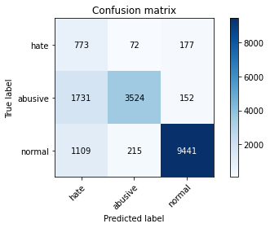

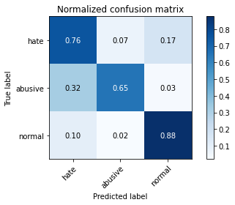

precision recall f1-score support

hate 0.21 0.76 0.33 1022

abusive 0.92 0.65 0.76 5407

normal 0.97 0.88 0.92 10765

accuracy 0.80 17194

macro avg 0.70 0.76 0.67 17194

weighted avg 0.91 0.80 0.84 17194

average eval_loss: 0.4881224607918845, accuracy: 0.7989996510410609

training 3 epoch...

237.38068437576294 seconds used......

3 training finished! average train loss: 0.29779975314710805

evaluating...

Confusion matrix, without normalization

[[ 812 85 125]

[1768 3477 162]

[1707 243 8815]]

Normalized confusion matrix

[[0.79452055 0.08317025 0.1223092 ]

[0.32698354 0.6430553 0.02996116]

[0.15856944 0.02257315 0.81885741]]

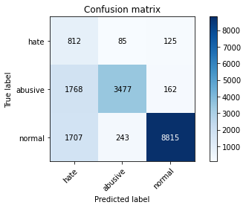

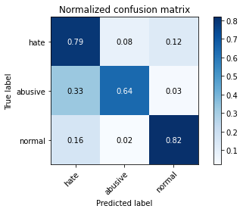

precision recall f1-score support

hate 0.19 0.79 0.31 1022

abusive 0.91 0.64 0.75 5407

normal 0.97 0.82 0.89 10765

accuracy 0.76 17194

macro avg 0.69 0.75 0.65 17194

weighted avg 0.90 0.76 0.81 17194

average eval_loss: 0.6797141167226919, accuracy: 0.7621263231359776

training 4 epoch...

237.34755063056946 seconds used......

4 training finished! average train loss: 0.19696133438514601

evaluating...

Confusion matrix, without normalization

[[ 827 87 108]

[1847 3456 104]

[2250 229 8286]]

Normalized confusion matrix

[[0.80919765 0.0851272 0.10567515]

[0.34159423 0.63917144 0.01923433]

[0.20901068 0.02127264 0.76971667]]

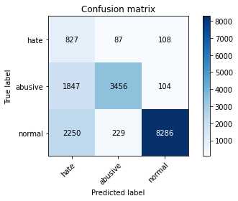

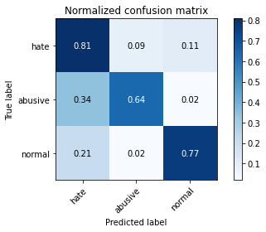

precision recall f1-score support

hate 0.17 0.81 0.28 1022

abusive 0.92 0.64 0.75 5407

normal 0.98 0.77 0.86 10765

accuracy 0.73 17194

macro avg 0.69 0.74 0.63 17194

weighted avg 0.91 0.73 0.79 17194

average eval_loss: 0.8521646565995937, accuracy: 0.7310108177271141

training 5 epoch...

237.43834447860718 seconds used......

5 training finished! average train loss: 0.1373947989269166

evaluating...

Confusion matrix, without normalization

[[ 779 102 141]

[1671 3577 159]

[1628 241 8896]]

Normalized confusion matrix

[[0.76223092 0.09980431 0.13796477]

[0.30904383 0.66154984 0.02940633]

[0.15123084 0.02238737 0.82638179]]

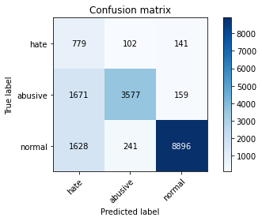

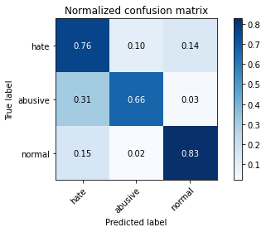

precision recall f1-score support

hate 0.19 0.76 0.31 1022

abusive 0.91 0.66 0.77 5407

normal 0.97 0.83 0.89 10765

accuracy 0.77 17194

macro avg 0.69 0.75 0.65 17194

weighted avg 0.90 0.77 0.82 17194

average eval_loss: 0.8260675133769075, accuracy: 0.77073397696871

3 run...

training 1 epoch...

237.40358996391296 seconds used......

1 training finished! average train loss: 0.6085459295298661

evaluating...

Confusion matrix, without normalization

[[ 875 45 102]

[2403 2893 111]

[2002 136 8627]]

Normalized confusion matrix

[[0.85616438 0.04403131 0.09980431]

[0.44442389 0.53504716 0.02052894]

[0.18597306 0.01263353 0.8013934 ]]

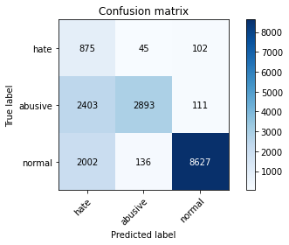

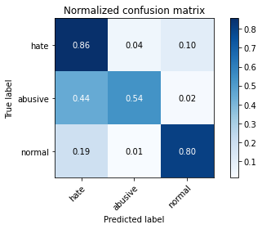

precision recall f1-score support

hate 0.17 0.86 0.28 1022

abusive 0.94 0.54 0.68 5407

normal 0.98 0.80 0.88 10765

accuracy 0.72 17194

macro avg 0.69 0.73 0.61 17194

weighted avg 0.92 0.72 0.78 17194

average eval_loss: 0.595606043466995, accuracy: 0.7208910084913341

training 2 epoch...

237.57634687423706 seconds used......

2 training finished! average train loss: 0.4350353898837927

evaluating...

Confusion matrix, without normalization

[[ 783 101 138]

[1447 3808 152]

[1333 234 9198]]

Normalized confusion matrix

[[0.76614481 0.09882583 0.13502935]

[0.26761605 0.70427224 0.02811171]

[0.12382722 0.02173711 0.85443567]]

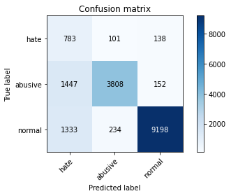

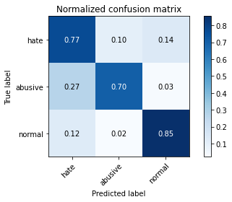

precision recall f1-score support

hate 0.22 0.77 0.34 1022

abusive 0.92 0.70 0.80 5407

normal 0.97 0.85 0.91 10765

accuracy 0.80 17194

macro avg 0.70 0.77 0.68 17194

weighted avg 0.91 0.80 0.84 17194

average eval_loss: 0.5045978746788446, accuracy: 0.8019658020239618

training 3 epoch...

237.46442461013794 seconds used......

3 training finished! average train loss: 0.30658092507020346

evaluating...

Confusion matrix, without normalization

[[ 768 104 150]

[1472 3743 192]

[1478 233 9054]]

Normalized confusion matrix

[[0.75146771 0.10176125 0.14677104]

[0.27223969 0.69225079 0.03550952]

[0.1372968 0.02164422 0.84105899]]

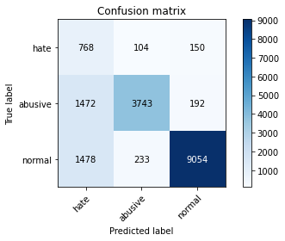

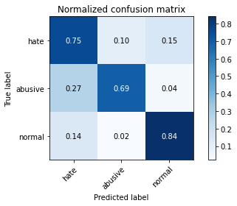

precision recall f1-score support

hate 0.21 0.75 0.32 1022

abusive 0.92 0.69 0.79 5407

normal 0.96 0.84 0.90 10765

accuracy 0.79 17194

macro avg 0.70 0.76 0.67 17194

weighted avg 0.90 0.79 0.83 17194

average eval_loss: 0.555520613981021, accuracy: 0.788938001628475

training 4 epoch...

237.37770438194275 seconds used......

4 training finished! average train loss: 0.20037665811806715

evaluating...

Confusion matrix, without normalization

[[ 758 136 128]

[1375 3887 145]

[1758 292 8715]]

Normalized confusion matrix

[[0.74168297 0.13307241 0.12524462]

[0.25429998 0.71888293 0.02681709]

[0.16330701 0.02712494 0.80956804]]

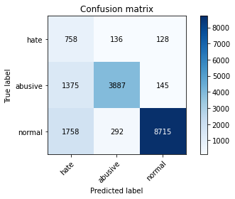

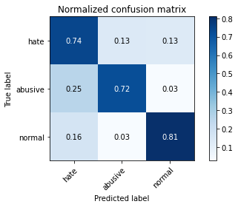

precision recall f1-score support

hate 0.19 0.74 0.31 1022

abusive 0.90 0.72 0.80 5407

normal 0.97 0.81 0.88 10765

accuracy 0.78 17194

macro avg 0.69 0.76 0.66 17194

weighted avg 0.90 0.78 0.82 17194

average eval_loss: 0.7454683057801408, accuracy: 0.7770152378736769

training 5 epoch...

237.5349657535553 seconds used......

5 training finished! average train loss: 0.14256877404412688

evaluating...

Confusion matrix, without normalization

[[ 753 120 149]

[1464 3743 200]

[1501 246 9018]]

Normalized confusion matrix

[[0.73679061 0.11741683 0.14579256]

[0.27076013 0.69225079 0.03698909]

[0.13943335 0.02285183 0.83771482]]

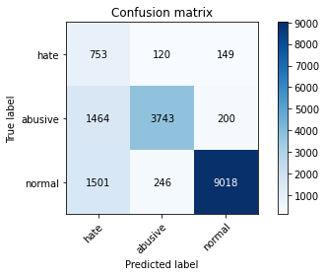

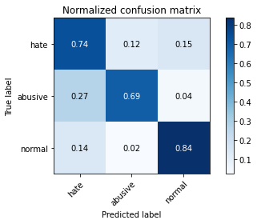

precision recall f1-score support

hate 0.20 0.74 0.32 1022

abusive 0.91 0.69 0.79 5407

normal 0.96 0.84 0.90 10765

accuracy 0.79 17194

macro avg 0.69 0.76 0.67 17194

weighted avg 0.90 0.79 0.83 17194

average eval_loss: 0.702485903693623, accuracy: 0.7859718506455741

4 run...

training 1 epoch...

237.57967686653137 seconds used......

1 training finished! average train loss: 0.6171758131504597

evaluating...

Confusion matrix, without normalization

[[ 770 108 144]

[1287 4001 119]

[1252 255 9258]]

Normalized confusion matrix

[[0.75342466 0.10567515 0.1409002 ]

[0.23802478 0.73996671 0.02200851]

[0.11630283 0.02368788 0.86000929]]

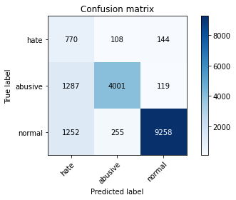

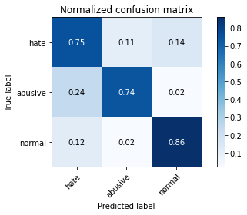

precision recall f1-score support

hate 0.23 0.75 0.36 1022

abusive 0.92 0.74 0.82 5407

normal 0.97 0.86 0.91 10765

accuracy 0.82 17194

macro avg 0.71 0.78 0.70 17194

weighted avg 0.91 0.82 0.85 17194

average eval_loss: 0.48620978129464526, accuracy: 0.8159241595905549

training 2 epoch...

237.40695428848267 seconds used......

2 training finished! average train loss: 0.43729026462571613

evaluating...

Confusion matrix, without normalization

[[ 731 105 186]

[1354 3838 215]

[ 942 214 9609]]

Normalized confusion matrix

[[0.71526419 0.10273973 0.18199609]

[0.25041613 0.7098206 0.03976327]

[0.08750581 0.01987924 0.89261496]]

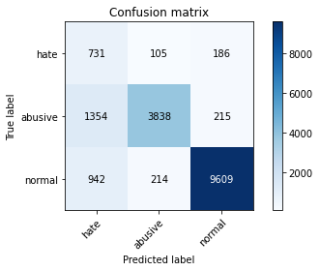

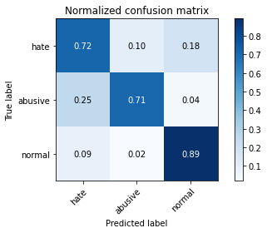

precision recall f1-score support

hate 0.24 0.72 0.36 1022

abusive 0.92 0.71 0.80 5407

normal 0.96 0.89 0.93 10765

accuracy 0.82 17194

macro avg 0.71 0.77 0.70 17194

weighted avg 0.91 0.82 0.85 17194

average eval_loss: 0.43232252570952096, accuracy: 0.8245899732464813

training 3 epoch...

237.40695309638977 seconds used......

3 training finished! average train loss: 0.30685506271656693

evaluating...

Confusion matrix, without normalization

[[ 754 147 121]

[1133 4145 129]

[1918 295 8552]]

Normalized confusion matrix

[[0.73776908 0.14383562 0.1183953 ]

[0.20954318 0.76659885 0.02385796]

[0.17817 0.02740362 0.79442638]]

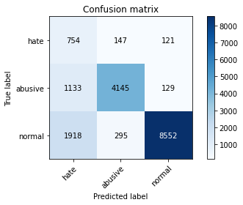

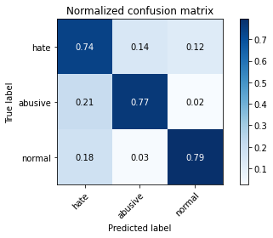

precision recall f1-score support

hate 0.20 0.74 0.31 1022

abusive 0.90 0.77 0.83 5407

normal 0.97 0.79 0.87 10765

accuracy 0.78 17194

macro avg 0.69 0.77 0.67 17194

weighted avg 0.90 0.78 0.83 17194

average eval_loss: 0.628396720352561, accuracy: 0.7823077817843433

training 4 epoch...

237.37266659736633 seconds used......

4 training finished! average train loss: 0.19722209808586952

evaluating...

Confusion matrix, without normalization

[[ 723 102 197]

[1522 3670 215]

[1055 224 9486]]

Normalized confusion matrix

[[0.7074364 0.09980431 0.1927593 ]

[0.28148696 0.67874977 0.03976327]

[0.09800279 0.02080817 0.88118904]]

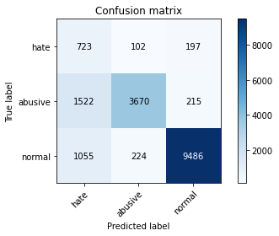

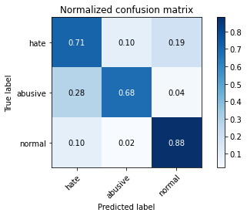

precision recall f1-score support

hate 0.22 0.71 0.33 1022

abusive 0.92 0.68 0.78 5407

normal 0.96 0.88 0.92 10765

accuracy 0.81 17194

macro avg 0.70 0.76 0.68 17194

weighted avg 0.90 0.81 0.84 17194

average eval_loss: 0.5676492928906323, accuracy: 0.8072001861114342

training 5 epoch...

237.31295371055603 seconds used......

5 training finished! average train loss: 0.13338952980153515

evaluating...

Confusion matrix, without normalization

[[ 610 189 223]

[ 834 4305 268]

[ 732 277 9756]]

Normalized confusion matrix

[[0.59686888 0.18493151 0.21819961]

[0.1542445 0.79619012 0.04956538]

[0.06799814 0.02573154 0.90627032]]

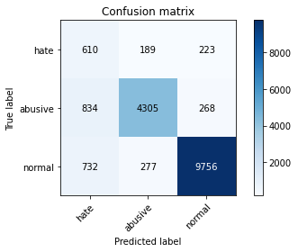

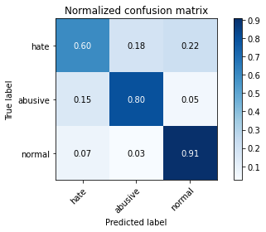

precision recall f1-score support

hate 0.28 0.60 0.38 1022

abusive 0.90 0.80 0.85 5407

normal 0.95 0.91 0.93 10765

accuracy 0.85 17194

macro avg 0.71 0.77 0.72 17194

weighted avg 0.90 0.85 0.87 17194

average eval_loss: 0.5567453642359523, accuracy: 0.8532627660811911

5 run...

training 1 epoch...

237.42632389068604 seconds used......

1 training finished! average train loss: 0.5938144043996156

evaluating...

Confusion matrix, without normalization

[[ 806 69 147]

[1716 3529 162]

[1434 196 9135]]

Normalized confusion matrix

[[0.78864971 0.06751468 0.14383562]

[0.31736638 0.65267246 0.02996116]

[0.13320948 0.01820715 0.84858337]]

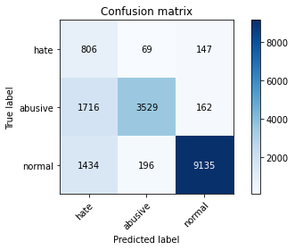

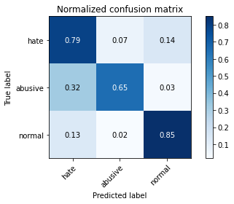

precision recall f1-score support

hate 0.20 0.79 0.32 1022

abusive 0.93 0.65 0.77 5407

normal 0.97 0.85 0.90 10765

accuracy 0.78 17194

macro avg 0.70 0.76 0.66 17194

weighted avg 0.91 0.78 0.83 17194

average eval_loss: 0.5227724700646345, accuracy: 0.783412818425032

training 2 epoch...

237.27196955680847 seconds used......

2 training finished! average train loss: 0.4304965425694769

evaluating...

Confusion matrix, without normalization

[[ 715 138 169]

[1011 4180 216]

[1106 249 9410]]

Normalized confusion matrix

[[0.69960861 0.13502935 0.16536204]

[0.18697984 0.77307194 0.03994822]

[0.10274036 0.02313052 0.87412912]]

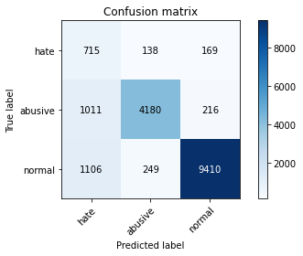

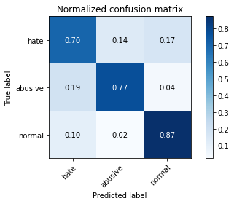

precision recall f1-score support

hate 0.25 0.70 0.37 1022

abusive 0.92 0.77 0.84 5407

normal 0.96 0.87 0.92 10765

accuracy 0.83 17194

macro avg 0.71 0.78 0.71 17194

weighted avg 0.90 0.83 0.86 17194

average eval_loss: 0.44774259782807774, accuracy: 0.8319762707921368

training 3 epoch...

237.65955567359924 seconds used......

3 training finished! average train loss: 0.3056887067837586

evaluating...

Confusion matrix, without normalization

[[ 789 104 129]

[1554 3718 135]

[1743 234 8788]]

Normalized confusion matrix

[[0.77201566 0.10176125 0.12622309]

[0.28740522 0.68762715 0.02496763]

[0.16191361 0.02173711 0.81634928]]

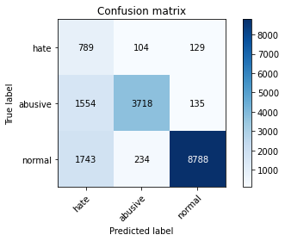

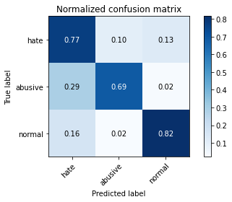

precision recall f1-score support

hate 0.19 0.77 0.31 1022

abusive 0.92 0.69 0.79 5407

normal 0.97 0.82 0.89 10765

accuracy 0.77 17194

macro avg 0.69 0.76 0.66 17194

weighted avg 0.91 0.77 0.82 17194

average eval_loss: 0.6288662854148898, accuracy: 0.7732348493660579

training 4 epoch...

237.87224650382996 seconds used......

4 training finished! average train loss: 0.19866278230235754

evaluating...

Confusion matrix, without normalization

[[ 786 90 146]

[1665 3582 160]

[1462 258 9045]]

Normalized confusion matrix

[[0.76908023 0.08806262 0.14285714]

[0.30793416 0.66247457 0.02959127]

[0.1358105 0.02396656 0.84022294]]

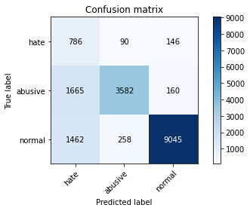

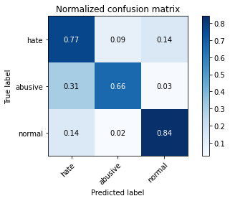

precision recall f1-score support

hate 0.20 0.77 0.32 1022

abusive 0.91 0.66 0.77 5407

normal 0.97 0.84 0.90 10765

accuracy 0.78 17194

macro avg 0.69 0.76 0.66 17194

weighted avg 0.90 0.78 0.82 17194

average eval_loss: 0.6662843704873392, accuracy: 0.7800977085029661

training 5 epoch...

237.40994548797607 seconds used......

5 training finished! average train loss: 0.1424998185506961

evaluating...

Confusion matrix, without normalization

[[ 809 111 102]

[1571 3723 113]

[2337 325 8103]]

Normalized confusion matrix

[[0.79158513 0.10861057 0.09980431]

[0.29054929 0.68855188 0.02089883]

[0.21709243 0.03019043 0.75271714]]

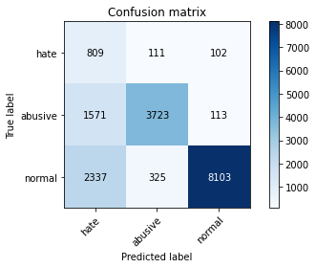

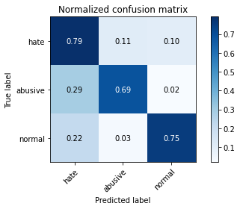

precision recall f1-score support

hate 0.17 0.79 0.28 1022

abusive 0.90 0.69 0.78 5407

normal 0.97 0.75 0.85 10765

accuracy 0.73 17194

macro avg 0.68 0.74 0.64 17194

weighted avg 0.90 0.73 0.79 17194

average eval_loss: 0.9459163521524778, accuracy: 0.7348493660579272